Exercise 1: Control Structures

1) Create the Tables
Query:
CREATE TABLE Customers (
CustomerID NUMBER PRIMARY KEY,
Name VARCHAR2(50),
Age NUMBER,
Balance NUMBER,
IsVIP VARCHAR2(10)
);

CREATE TABLE Loans (
LoanID NUMBER PRIMARY KEY,
CustomerID NUMBER,
InterestRate NUMBER,
DueDate DATE,
FOREIGN KEY (CustomerID) REFERENCES Customers(CustomerID)
);

Output (Table is created) :
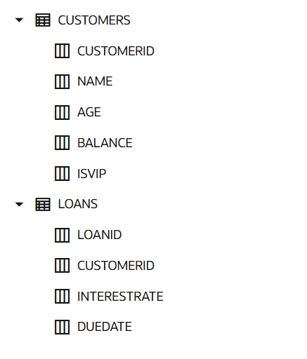

2) Insert Sample Data :
INSERT INTO Customers VALUES (1,'John',65,15000,'FALSE');
INSERT INTO Customers VALUES (2,'Alice',45,8000,'FALSE');
INSERT INTO Customers VALUES (3,'David',70,20000,'FALSE');

INSERT INTO Loans VALUES (101,1,10,SYSDATE+20);
INSERT INTO Loans VALUES (102,2,12,SYSDATE+40);
INSERT INTO Loans VALUES (103,3,11,SYSDATE+15);

COMMIT;

Output:
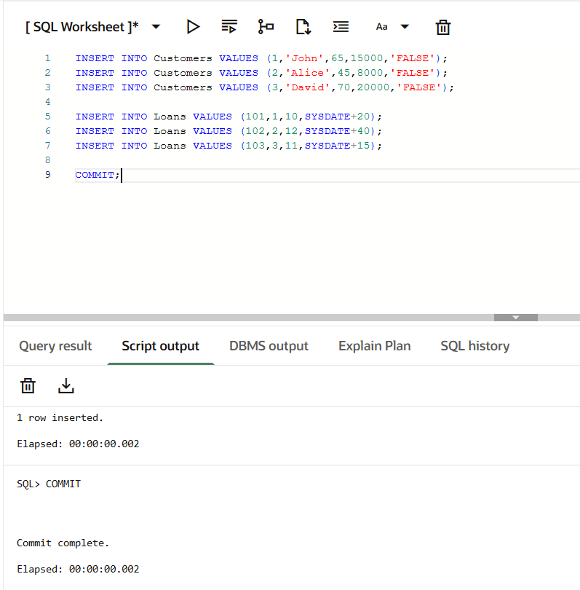

3) Scenario 1:
Apply 1% Interest Discount
BEGIN
FOR cust IN (
SELECT CustomerID
FROM Customers
WHERE Age > 60
)
LOOP
UPDATE Loans
SET InterestRate = InterestRate - 1
WHERE CustomerID = cust.CustomerID;
END LOOP;

COMMIT;
END;
/
Output :
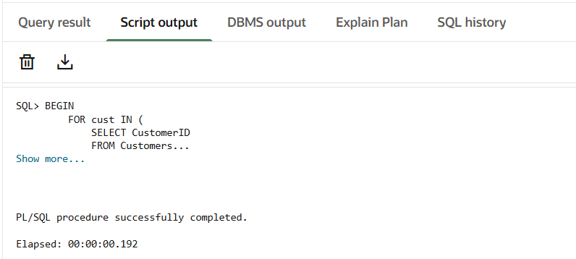

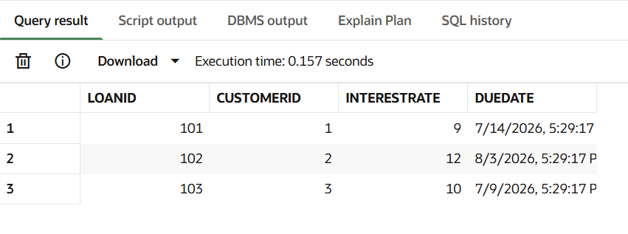
4) Scenario 2
Set VIP Customers
BEGIN
FOR cust IN (
SELECT CustomerID
FROM Customers
WHERE Balance > 10000
)
LOOP
UPDATE Customers
SET IsVIP = 'TRUE'
WHERE CustomerID = cust.CustomerID;
END LOOP;

COMMIT;
END;
/
Output:

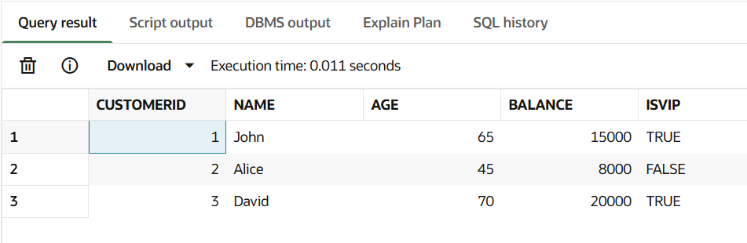

5) Scenario 3
Loan Reminder Program

BEGIN
FOR loan_rec IN (
SELECT c.Name,
l.LoanID,
l.DueDate
FROM Customers c
JOIN Loans l
ON c.CustomerID = l.CustomerID
WHERE l.DueDate BETWEEN SYSDATE
AND SYSDATE + 30
)
LOOP
DBMS_OUTPUT.PUT_LINE(
'Reminder: Dear '
|| loan_rec.Name
|| ', your Loan ID '
|| loan_rec.LoanID
|| ' is due on '
|| TO_CHAR(loan_rec.DueDate,'DD-MON-YYYY')
);
END LOOP;
END;
/
Output :
